1)
– 50Hz/60Hz Powerline interference and its harmonics
- Can be removed with bandstop filter
- We might accidentally remove some signal of interest which has the same frequency than powerline interference has.
- Poor skin-electrode contact
- Can be prevented by careful cleaning of connection points and adding gel if the electrodes do not stay still.
- Affects random low-frequency artifact in ECG-signal, which cand be removed by filtering ( for example with SA-filter).
-Breathing, coughing and moving
- Also affects a low-frequency artifact in chest-lead ECG
- Can be prevented by measuring the patient in relaxed conditions.
- Random coughs and moving can be removed for example with SA-filter
- Breathing could be removed by using adaptive filtering because it usually is quite repetitive.
-Another biosignal foe example parental ECG added in fetal ECG.
- Affects corruption to the signal of interest
- Can be removed with adaptive filtering (ANC) with reference signal which is correlated with noise that we want to remove.
- Removing might be difficult if the noise signal is not synchronized.

2)
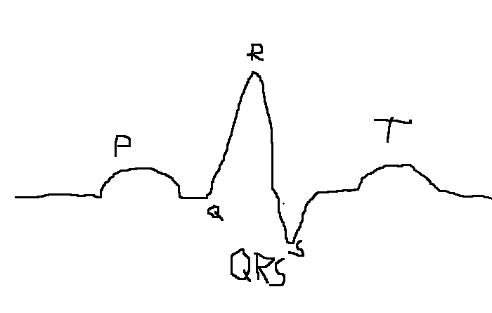
- Lowpass filter with a cutoff frequency of 40Hz removes thickened parts which are unimportant high frequency components of signal (for example powerline interferency). Important data frequencies are between 0.05-35Hz.
- Highpass filter with the cutoff frequency of 5Hz removes the baseline wandering caused by low frequency artifacts for example breathing, coughing and poor electrode contacts. Additionally it removes the P and T peaks . Powerline interference stays.

3)

There various filters which can be used. For IIR signals we have filters like Butterworth and Chebyshev. All of them are working with the same concept.

First you have to define your frequency limits, sampling rate and order. Then for Butterworth filter you input these to command butter. The output of command is coefficients, which define the transfer function.

Examples:

Highpass:

[b, a] = butter(order, fc/(fs/2), 'high');

Where fc is the midpoint of the transferband.

Lowpass:

[b, a] = butter(order, fc/(fs/2), 'low');

Bandpass:

[b, a] = butter(order, [f_low/(fs/2), f_high/(fs/2)], 'bandpass');

Bandstop:
[b, a] = butter(order, [f_low/(fs/2), f_high/(fs/2)], 'stop');

For Chebyshev filters the corresponding commands are cheby1 and cheby2.

After you have got the coefficients, you can create a filtered signal with a command filter.
filtered_signal = filter(b, a, original_signal);

Other possible filter types are for example designfilt and fir1. FIR and IIR signals requires a different kind of filters.

4)
Synchronized averaging requires many signals and it takes data points from the same point in time across different realizations, calculates the average and creates a new point. SA-filter takes many reference points so it can create a new averaged signal.
In temporal averaging, the average is calculated over different points in time in the same data sequence. When the filter goes through every sequences of the signal it can create a new signal based on averages. So, temporal averaging uses only one signal.

5)
Synchronized averaging fail to reduce noise if the noise is correlated with the signal of interest. If the same noise appears at same points in every signal, averaging will not reduce it effectively. Also if the noise is non-stationary it might affect big differences between measures and then averaging is not reducing noise. SA is not possible if multiple realizations are not available.

Minor mistakes and additions but 2/2

